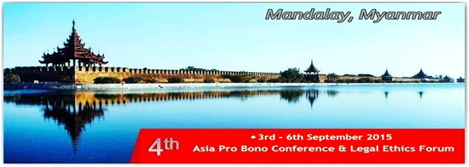

The 4th Asia Pro Bono Conference & Legal Ethics Forum was held in Mandalay, Myanmar from the 3rd to the 6th of September, 2015. The conference and forum hosted 230 delegates from 19 countries from across the legal community including lawyers, legal educators, students, judges, government officials, and civil society professionals. The theme of the conference and forum was “Pro bono and ethics build a noble legal profession.” It was an inspiring exhibition of a strong commitment to pro bono, legal ethics and justice education in the region and internationally.

The conference and forum was co-organized by Bridges Across Borders Southeast Asia Community Legal Education Initiative (BABSEA CLE) and an international consortium comprised of law firms, law societies, legal education institutions, access to justice-related organizations, and others. Delegates from around the world attended to continue the momentum of the pro bono and legal ethics movements, to propel them forward, and to recognize the successes and connections established by the previous three conferences. The first conference was held in Vientiane, Laos in 2012, the second in Ho Chi Minh City, Vietnam in 2013, and the third in Singapore last year. This year’s conference and forum took place at the Wilson Hotel, located in the heart of Mandalay.

On September 2nd, the 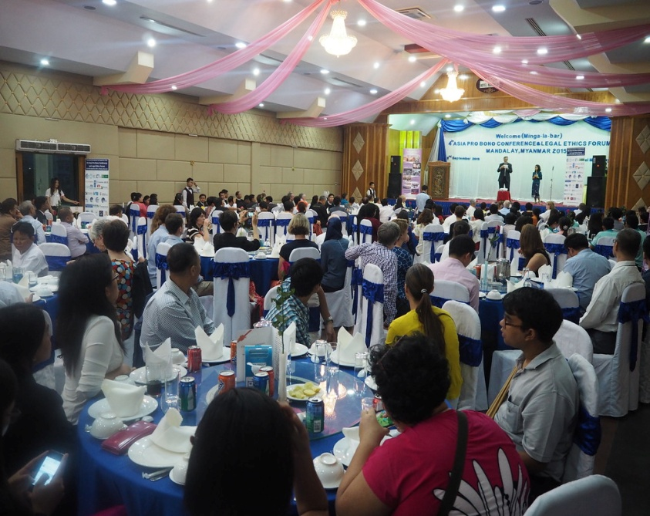day before the conference and forum, an evening welcome reception and dinner took place at Hotel Mandalay. This festive pre-opening to the conference and forum included an entertaining cultural presentation by a local Myanmar acting troupe, the Human Drama Group. The dinner reception laid the foundation for an ambitious and informative agenda as well as providing recognition for Myanmar’s first TV legal drama called “The Sun, the Moon, and the Truth.” Grace Swe Zin Htaik, the producer of the legal drama, announced the exciting news that over one million viewers had tuned-in to view this groundbreaking production. This TV series was seen as a way to make pro bono more accessible and relevant in the minds of the Myanmar people.

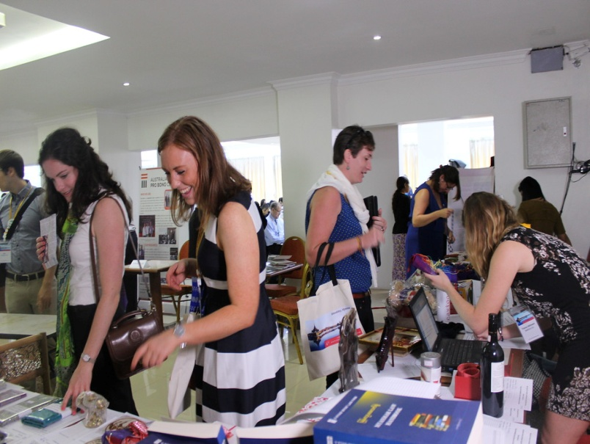A number of conference and forum consortium partner organizations and other NGO’s were invited to engage in a Marketplace of Ideas by setting up information booths at the conference to present their work and network with other delegates. This setting provided a unique opportunity for organizations, law firms, governmental entities, and academic institutions to engage with one another and exchange ideas about pro bono services. Leni Widi Mulyani, a law teacher and street law clinician from Pasundan University in Indonesia said, “It was greatly helpful for me to meet international organizations, lawyers and law professors.”

A new addition to this year’s pro bono conference and legal ethics forum was a silent auction. Delegatesdonated items from numerous countries from around the globe to be bid on. All the proceeds went to the victims of the recent devastating Myanmar flood. Theauction operated simultaneously throughout the conference and forum and offered the delegates a chance to bid on interesting items, help make positive change in the local community, and continue to network with other delegates all at the same time. The silent auction turned out to be a huge success as it raised over two million kyat or over $1,500 USD. The funds were donated to the Free Funeral Services Society and the Sidagu Association to provide direct aid to the flood victims.

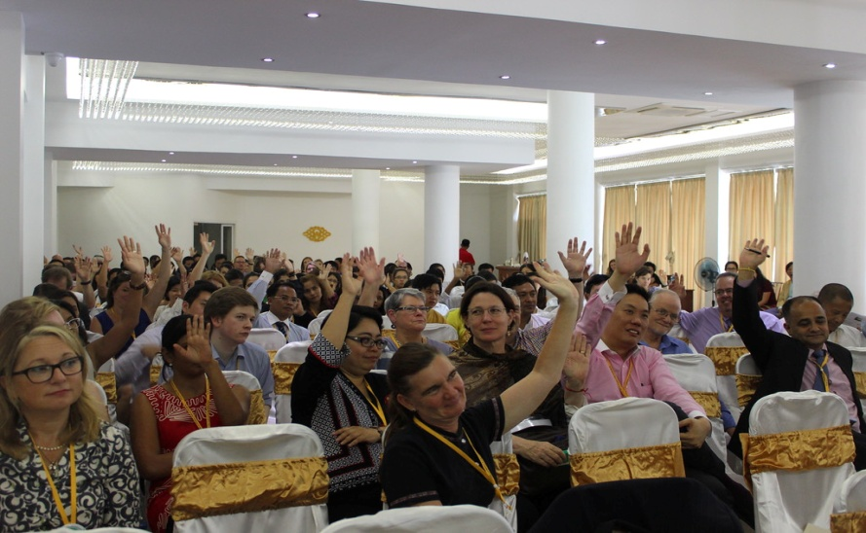The conference and forum was kicked off by Bruce Lasky, a Co-Founder and Co-Director of BABSEA CLE, who utilized an inspirational quote from an iconic African American tennis player, Arthur Ashe, “start where you are, use what you have, do what you can,” to summarize what pro bono and legal ethics was all about and what principles they were founded on. He had the participants repeat back the quote and, with this simple act of solidarity, the tone was set for the entire conference and forum.

U Hla Ko, an advocate from Myanmar, delivered the keynote address. A video was presented that illuminated the power of pro bono through two legal cases; one that U Hla Ko’s law firm, Mandalay Law Firm, had won, and the other which was still pending. The presentation demonstrated his dedication and that of his law firm to pro bono and highlighted the great potential for sustained success of pro bono in Myanmar and the region. Excellent simultaneous translation, through a large group of volunteers, was offered in Myanmar and English throughout the entire conference and forum.

Following the keynote address, Day 1 featured a plenary session that asked the question, “What do we mean by pro bono and what are its ethics?” The first speaker, Professor Adrian Evans from Monash University in Australia, analyzed a common mistake of assuming that pro bono is automatically ethical. Through this collaborative discussion, the participants explored the relationship between ethics and pro bono. A second plenary session took place shortly after that focused on identifying the legal needs and challenges that face access to justice and legal aid in Asia and how pro bono might help overcome these challenges. Each session involved a panel of three to four speakers with a facilitator to generate a constructive dialogue between the panelists and delegates. Throughout the conference and forum, presentations utilized various interactive clinical legal education (CLE) methodologies including debate, role-plays, group and partner discussions, questions and answers, drawing and power points, to name just a few.

Following the morning and a partial afternoon of plenary sessions, Day 1 culminated in the late afternoon with six breakout sessions, allowing delegates to congregate in smaller, more intimate settings while having the freedom to choose what topics best suited their interests and needs. Topics ranged from “Overcoming challenges of replicating pro bono programme success,” to “Small firm pro bono,” “Showcasing successful pro bono partnerships in the region,” and “Pro bono, corporate social responsibility: Differences and synergies.”

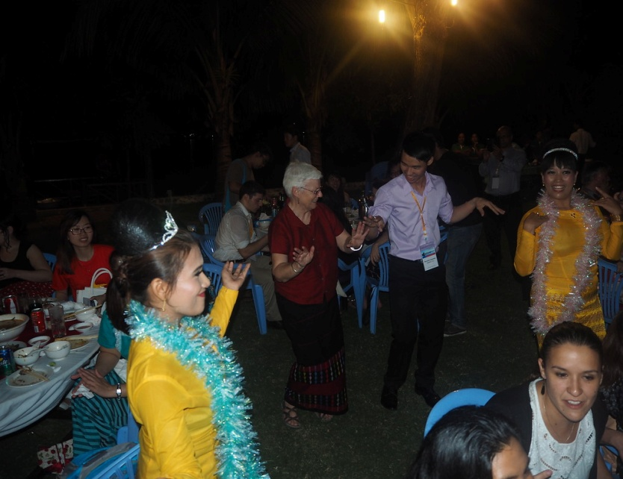Day 2 began with opening remarks by the Immediate Past President of LAWASIA and advocate from Joyce A Tan and Partners, Malathi Das. She coordinated her address by referring to the “pro bono tree” of structure, culture, and nurture. In an elegant metaphor she described how the trunk of the tree was its structure providing the logistics and the practical aspects of pro bono. Values and culture were the roots of the tree, keeping it strong and firmly in place. Finally, she predicted that if we nurture the tree by working hard and staying ethically disciplined, we would reap the delicious fruit of justice. The bulk of the conference and forum’s breakout sessions were offered on Day 2 with the total for the day coming to 20. Some of the topics discussed were, “The relationship between pro bono and legal aid,” and “Encouraging and coordinating pro bono.” Plenary session 3 followed and the participants explored the role of bar associations in supporting pro bono. Two more blocks of breakout sessions brought the day to a close before a celebratory dinner at the Kot Ko Island Restaurant.

Not only was the dinner outside and surrounded by palm trees and brisk blue waters, but the venue included a chance for delegates to present a cultural display of singing, dancing or both from their respective countries. Myanmar, being the host country, kicked off the cultural performances which turned out to be much, much more. A melting pot of culture ensued as delegates crossed cultural boundaries and joined in with other countries and vice versa. A symbolic washing away of barriers and a demonstration of how the power of pro bono, ethics, and service can bring communities together closed the night.

As the conference and forum reached the half-way point, the focus shifted toward students, youth, and the next generation of ethically guided pro bono champions. Students were given the chance to present what they had done and learned while studying and doing pro bono. The day started with the stage adorned with students and that would be the theme for the duration of the day. The first session saw law students from Australia, Laos, and Thailand discuss how pro bono had changed their lives for the better, how they had made a difference in their communities, and felt empowered by this enriching tool for good. The next two sessions identified and aimed to answer the questions of whether law professors should do pro bono and whether student pro bono should be mandatory.

In order for the pro bono movement to grow and prosper, it is essential to measure and evaluate the many aspects of work that is done. With students and their projects, it is no 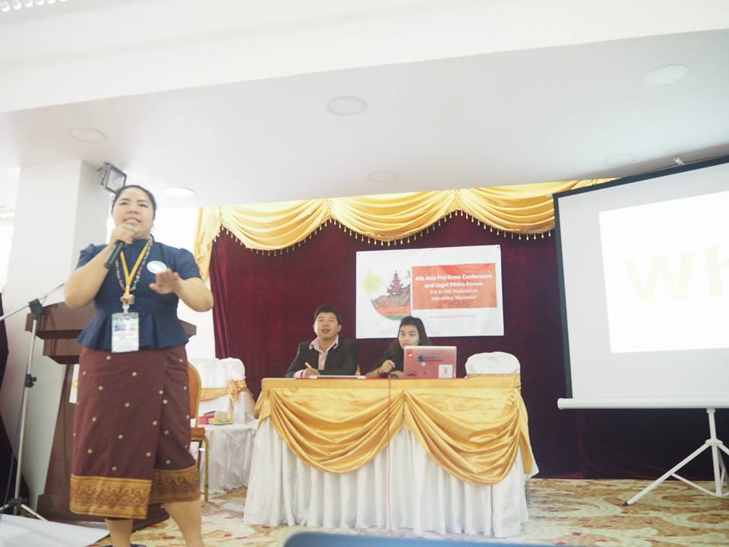different. That is why the next session was incredibly vital as students from around the region, who were present at the last conference in Singapore, displayed their work from then to now and examined their own progress, setbacks, and opened up for an interactive conversation. The student-focused theme continued as the next session investigated the ways in which the student-lawyer relationship could be strengthened when it came to pro bono. Many ideas were generated such as having lawyers provide support for mock trials and law firms offering externship programmes where students could become introduced to pro bono.

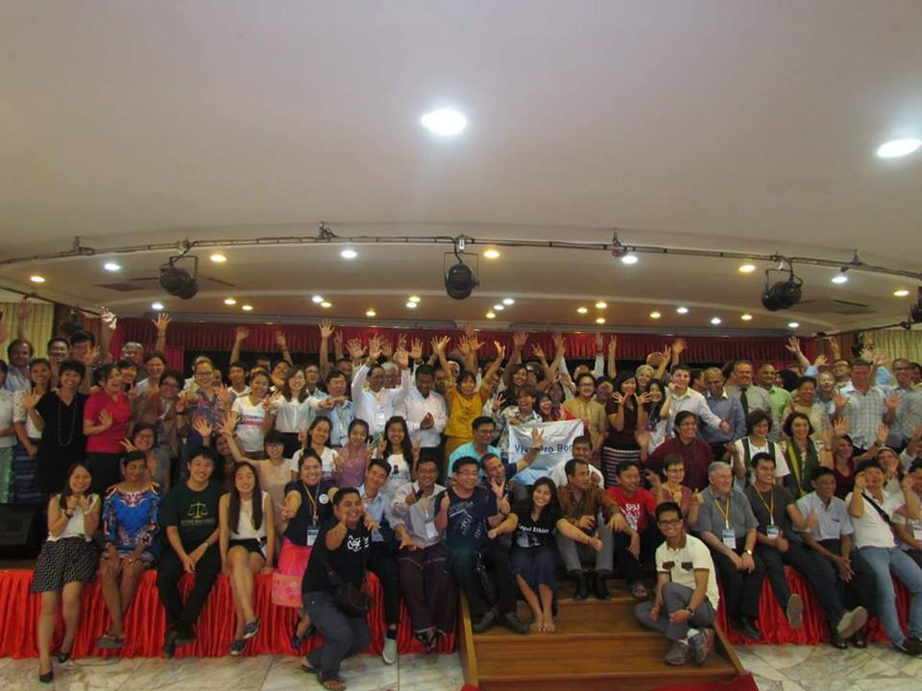The dinner for Day 3 was co-hosted by the Southeast Asia Legal Aid Network (SEALAW), which is an association of legal aid providers, social justice advocates, and community organizers working collaboratively to bring access to justice to the region, as well as the conference and forum organizers. SEALAW utilized this evening dinner to hold a general open informational meeting to organize and announce ways for the delegation to become involved. The dinner took place at the breathtaking Jin Taw Chinese Buddhist Temple. Before dinner, following the tradition first began in Laos, the conference and forum flag was ceremoniously passed from the Myanmar to the Indonesian delegation. U Hla Kohanded the “Viva Pro Bono” flag to Ni Luh Gede Yastini, Chairperson of Bali Legal Aid,to signify that the next conference and forum would take place in Indonesia. Yastinigraciously accepted the flag and briefly spoke about the importance of pro bono and its steady proliferation in Indonesia. Then, delegates who had contributed to the conference and forum were asked to come on stage by country. As the list of countries became exhausted, almost the entire delegation was now represented on stage. In a jubilant demonstration, the delegates received recognition for their past achievements, joined in celebration of their current collaboration, and anticipated their future success, together.

The last day of the event was the legal ethics forum, which opened with a lesson about strengthening ethical judgments. Three ethical methods were presented; Kantian, Consequence, and Virtue ethics. The delegation was separated in three groups and assigned an ethical method and various ethical dilemmas. Plenary 4 focused directly on the main theme of the conference and forum as it posited the question of how to develop a noble legal profession through pro bono. Famous lawyers that many people admired, like Nelson Mandela, were dissected in terms of what made them good and ethical lawyers. The audience was challenged to take on the same characteristics as these iconic figures. Two separate blocks of breakout sessions proceeded. Some of the breakout session topics were the following: “Regulation and sanctions of the legal profession,” “Meeting clients and trusting a lawyer, “Comparing professional conduct rules of countries within the region and internationally,” “Avoiding conflict of interests,” and “Duty of confidentiality.”

The 4th Asia Pro Bono Conference & Legal Ethics Forum was a monumental leap forward and will have a positive effect on the future success of pro bono, legal ethics and justice education in the region and worldwide. John Corker, the Director of the Australian Pro Bono Centre, summed up the conference and forum well when he stated, “This conference has evolved from year to year and country to country, to bring together a unique mix of international and local issues. The conference has the legacy of leaving behind a strengthened local legal profession and pro bono culture. This year was no exception.”

See you next time in Indonesia for another inspiring event and, in the meantime, keep calm and do pro bono.

Many thanks to all the supporters of the conference and forum:

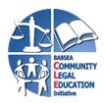





https://lh5.googleusercontent.com/JxvMZAnyqLW2tDIlDjPqHF9BkC1T_kfS0uugn3AS-l3Q38f6tT2q2jpgW9nSBjbRY3EHG5JV3lZgRUkwS2XrAJPaDsOezENabq9WyUAsD-gJW7UQQes0P5f76CNJWgRL0g=s1600



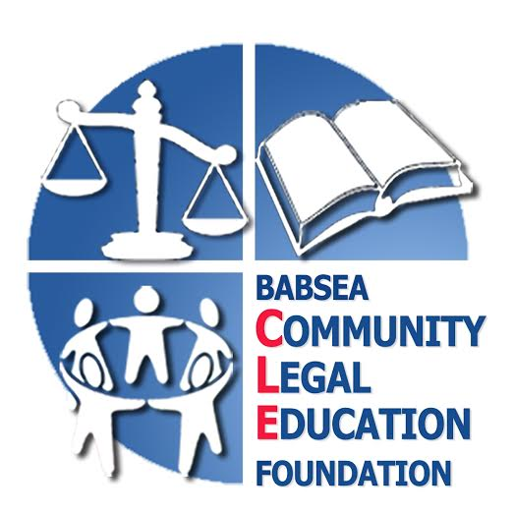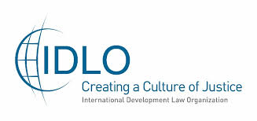

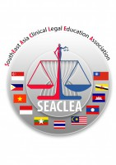

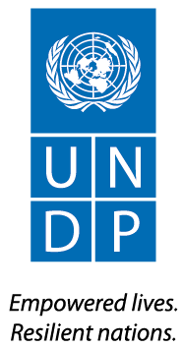



https://www.probonoconference.org/wordpress/wp-content/uploads/2015/08/SEALAW-Logo-1-200x45.jpg

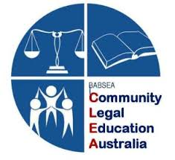

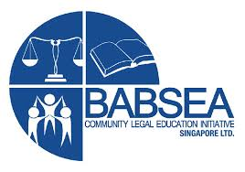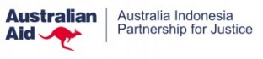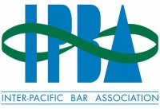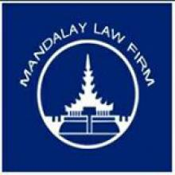https://lh4.googleusercontent.com/kcnZ-BJu3nDcgx5YzR0sNsCScusSXF6Ff8iUTs1_ftp1_001blkMAP24iFYM2Z7_YGIMuV_JBcpJbOjkJr55R3YWH13SDuSpg0gLKps0FlnU8BuwLvEmJgrdfv8-plwiSQ=s1600